|  |  |
| --- | --- |
|  | |
|  | |
| [Report Title] | |
| **Module code:** | **[4 digit code]** |
| **Module name:** | **[Module name]** |
|  | |
| [Date of submission] | |
|  | |
| **Author(s):** | **[Author name]** |
| **Student ID(s):** | **[Number]** |
| **Degree:** | **[e.g. MEng Aerospace Engineering with Industry]** |
| **Tutor/Project supervisor:** | **[Name]** |
|  | |
| **CO-INVESTIGATOR: [Enter name here] [For 1st year labs only – delete this line for all other reports]** | |
| **SUPERVISOR’S COPY/EXAMINER’S COPY [For 3rd/4th year projects only - delete as appropriate] [Delete this line for all other reports]** | |

|  |
| --- |
|  |
| Summary |
| [Enter summary text here] |

Contents

1 Introduction {Paul} Real world applications , requirements 2

1.1 List of members 2

1.1 Chassis (Brad) 2

1.2 Design (Alex) 2

1.3 Powertrain (Keqi) 2

1.4 (Paul) 2

1.5 (Divine) 3

1.6 (Xiang) 0

2 The criteria derived from the specifications for the design to meet the system requirements and the rules; (Brad) 0

3 A requirement tree {Divine} 0

4 A morphological diagram or mind-map showing the range of solutions or devices considered for concepts; (Keqi) 1

5 A sketch and corresponding description of each concept presented in the first VDP meeting. The name of the "designer" should be written on the sketch together with some reference number or text to the synthesis chart 0

5.1 Chassis (Brad) 0

5.2 Design (Alex) 0

5.3 Powertrain (Keqi) 0

5.4 (Paul) 0

5.5 (Divine) 0

5.6 (Xiang) 0

6 Synthesis chart Sort of VDP2 {Do together on monday} 0

7 Materials & Pricing {Alex} 0

8 Conclusion on design After VDP2 {Xiang} does introductory paragraph 0

8.1 Chassis (Brad) 1

8.2 Design (Alex) 1

8.3 Powertrain (Keqi) 1

8.4 (Paul) 1

8.5 (Divine) 1

8.6 (Xiang) 0

# Introduction {Paul} Real world applications , requirements

This template is designed to be used with the Department Technical Writing Handbook for students, which details the standards you are expected to follow. The section headings in this template are examples commonly used for a laboratory report. For project reports in later years, the section headings and structure of the report should be discussed with your supervisor, because they may be different, specially for software or control projects.

Examples of tables, figures, equations and examples of references for a textbook [1], journal paper [2] and webpage [3] are included which can be used as a template for these features in your report.

## List of members

## Chassis (Brad)

3-4sentences  
link back to spec

Roles and responsibility

## Design (Alex)

3-4sentences  
Roles and responsibility

## Powertrain (Keqi)

3-4sentences Roles and responsibility

## (Paul)

3-4sentences Roles and responsibility

## (Divine)

3-4sentences Roles and responsibility

## Payload (Xiang) As the payload engineer in our group, Payload engineer is responsible for design the appearance of the payload and arrange the position of each component on the hovercraft such as fans and load area. At the same time, payload engineer needs to adjust the location of components to help the hovercraft keep balance. Balance is the precondition for running the hovercraft.

# The criteria derived from the specifications for the design to meet the system requirements and the rules; {Brad}

# A requirement tree {Divine}

|  |  |  |
| --- | --- | --- |
| Wish: | Requirement: | Specification: |
|  |  |  |
|  |  |  |

# A morphological diagram or mind-map showing the range of solutions or devices considered for concepts; {Keqi}

**Blaaaaaa**

**aaaaaaaaah;**

.

# A sketch and corresponding description of each concept presented in the first VDP meeting. The name of the "designer" should be written on the sketch together with some reference number or text to the synthesis chart

## Chassis (Brad)

## Design (Alex)

## Powertrain (Keqi)

## (Paul)

## (Divine)

## Payload (Xiang)

In the VDP 1, we made three hypotheses about the payload area.

In the first hypothesis, there are one propulsion fan and one lift fan. The lift fan is located on the front part and the propulsion fan is located on the pack part of the hovercraft. The load area is on a small table which is placed above the lift fan. The position of a battery is between the lift and the propulsion fan.

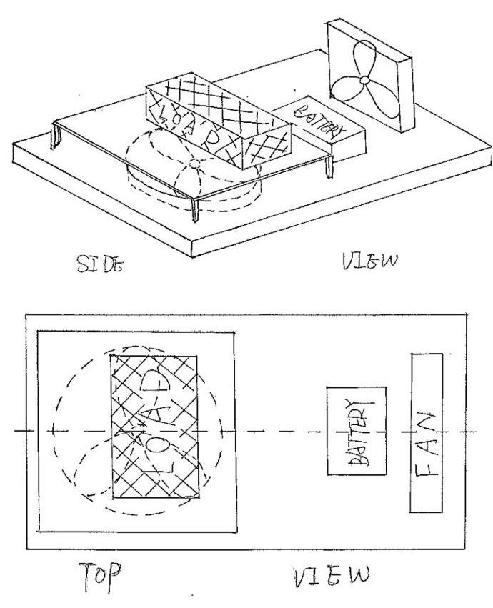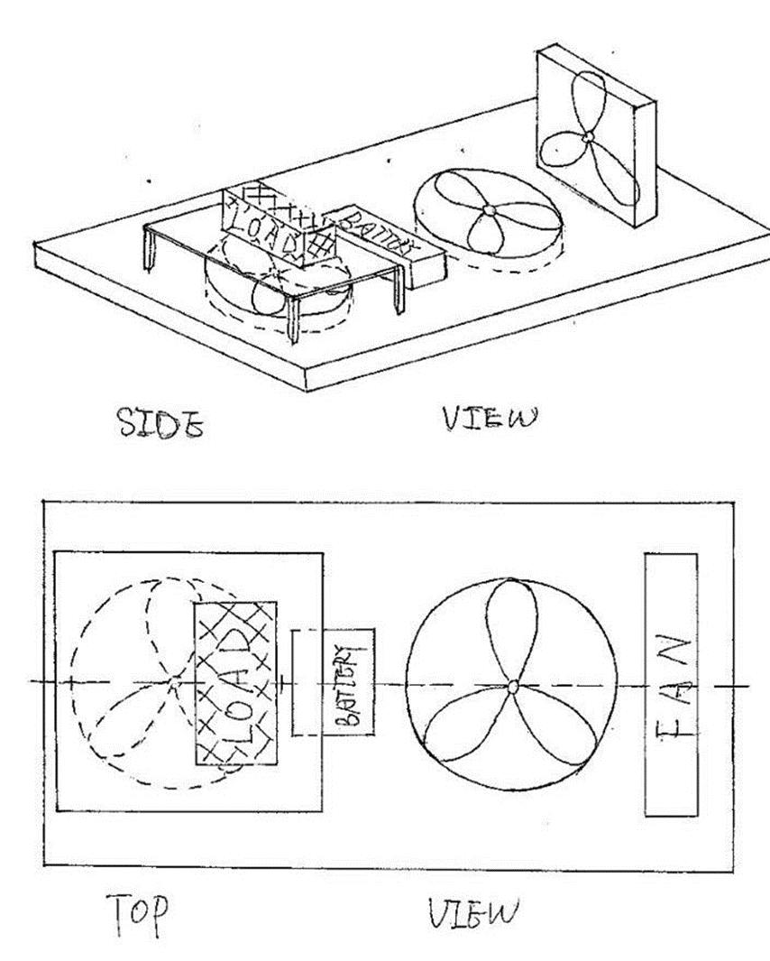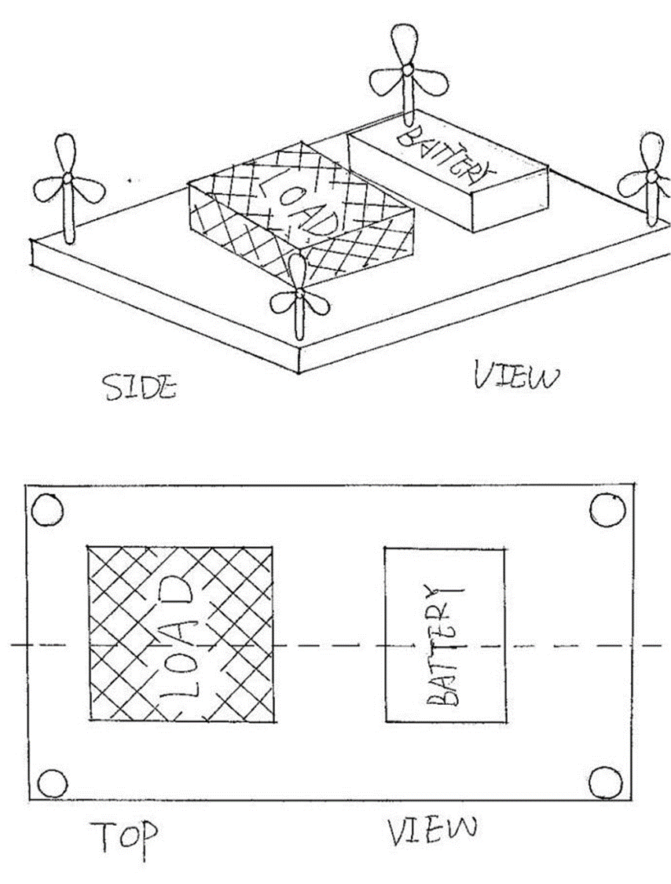

1 2 3

In the second one, we designed two lift fans and one propulsion fan. The prolusion fan is in the back part, one of the lift fan is just in front of the back fan the other one is in the upper part. This hypothesis is very similar to the first hypothesis, one more lift is used to help to control the balance.

The last one has four small propulsion fans placed in every corner of the payload area and one lift fan in the front. The load area is just above the lift fan and the battery placed behind it.

Around these three, we chose the second hypothesis. Because the two lift fans can provide more power than the other two. They can help the control the balance by changing the place of the lift fan as well. Also, all of the apparatus in this area should be symmetrical as much as possible to control the balance.

Dimensions are showing below:

|  |  |  |
| --- | --- | --- |
| Name | Length x width x thickness/mm | Weight/g |
| Payload area | 415 x 292 x 25 | 340(without load) |
| Battery | 74 x 55 x 20 | 145 |

|  |  |  |
| --- | --- | --- |
| VDP1 | Goes to… | VDP2 |
| 2 lift fans | **1 lift fan** |
| 1 load area | **3 load areas** |
| Load area above the lift fan | **Load area around battery** |
| Cowling is a circle | **Cowling is a square** |
| No support for motor | **Motor holder provided** |

Calculations (VDP2 stuff)

# Synthesis chart Sort of VDP2 {Do together on monday}

* **Completed synthesis chart ( or charts if a second iteration is attempted) showing:**
  + **The specifications considered;**
  + **The weightings for each criterion;**
  + **The marks for each design concept and the totals**

**Completed as a group**

**Bring every solid works design + sketches**

# Materials & Pricing {Alex}

Material Descision

# Conclusion on design After VDP2 {Xiang} does introductory paragraph

* **Concluding section stating the outcome of the selection process and giving outline details of the final design with the division of task to sub-groups.**

Using the feedback from the VDP meetings, we have updated and improved our model to improve the designs. The hovercraft as a whole need to lie within the specification. The body cannot be larger than 420 x 297mm, but still needs to have the skirt. We want the payload area to be light as as possible to reduce the total weight so we can have a larger load. The finial design of the rudders should be in a symmetrical aerofoil shape to redirect the most airflow possible. When we chose the materials, we tried to find a light, strong and cheap one which can be easily changed to suit our needs. For the lift blower, it needs to produce high pressure whilst only using a low amount of power. When deciding a servo, we want it to be cheap, light and closed loop. This helps to give accurate control and a high torque servo. The control system should get enough lift and be capable of overcoming small obstacles.

## Chassis (Brad)

## Design (Alex)

## Powertrain (Keqi)

## (Paul)

## (Divine)

## (Xiang)

The graph below is the finial design the payload area.

First of all, in order to control the balance of the hovercraft, nearly all the components should be placed symmetrically about the vertical centre line.

There are some grooves on the payload area, that is used for position the components into right place. The grooves help to fix the components and save area. Save area means the total weight will reduce as well, so we can put more load on the hovercraft. At the same time, all of the grooves should be a little larger than the actual dimension of the components. Because the dimension we found from the website may have errors, 1-2mm larger will help to fix them easier.

The lift fan is placed in the front part; it lays on the vertical centre line of the hovercraft. The hole of the blower is facing to the front. There will be a pipe connect the hole of the blower and the hole of lift fan area, so the blower can blow air to the chassis.

The propulsion fan is placed in the back part. The cowling is designed into square because square is more stable than circle. Four small sticks are stick at the back of the cowling. They are used to fix the rudders.

Servo area is just beside the cowling, because the servo is only 11g, I want to reduce the distance between the centre line and the servo as much as possible. It can be balance when we put the electrical components on as well.

The motor holder is located in front of the cowling. The cylinder area fixes the motor, and the centre of the cylinder is the same height as the centre of the propulsion fan. Therefore, the motor can connect the propulsion fan perfectly. Of course there is a groove under the holder to fit it.

Because of the weight in front and back part are different (shown in the table below), the position area is used to control the balance.

Horizontally symmetric---left hand side moment=right hand side moment

157.5 x 180 + (51+10) x 122 + 48 x 145 = 33 x 92 +200 x 20 x 2 + 200 x X

X =159 mm

